Nook COLOR – Borrow and Download Books
** FIRST TIME USE:
- You must authorize device with a free Adobe ID to before downloading first book.

- You’ll only have to do this once.

- Follow prompts to get an Adobe ID online or visit www.adobe.com first.

Install App:
- Visit the App Store and search for OverDrive Media Console app
- Download & install app. Tap icon (blue square, white O) to open.
- Tap the menu icon, then "Get Books"
- Tap "Add a Library", enter 06405, tap James Blackstone Memorial Library, then tap Libraries Online tap on star to save library
- Tap on Libraries Online text to open catalog search for title

To find and search for books:
- Open app -> Tap menu tap Get Books Tap on Libraries Online text to open catalog
- Search or browse for title if available, tap “Add to Cart” or if not, “Request/Hold”
- Confirm check-out, then tap Download
- Tap for menu -> tap Bookshelf to display checked out items
- Tap title to open/read item (to change font size/color: Tap in bottom of screen to see options)

To Return Item Early (book will automatically be returned otherwise)

From the Bookshelf screen:
- Tap Plus (+) sign next to book
- Tap Return/Delete
In opened book:
- Tap for menu tap Return/Delete
- Tap Return then Delete

Helpful Hints for Nook COLOR
- With Overdrive Media App, Nook Color devices are compatible with the ePUB ebook format or Overdrive Mp3 audiobook format.

- “Add to Cart” will be displayed near all books with “Available” copies

- Up to 6 titles can be placed on hold at one time

- Audiobook lending period = 10 days | E-book lending period = 14 days

- Pop-up screens with tips: uncheck “Show…” then close to stop seeing pop-up.

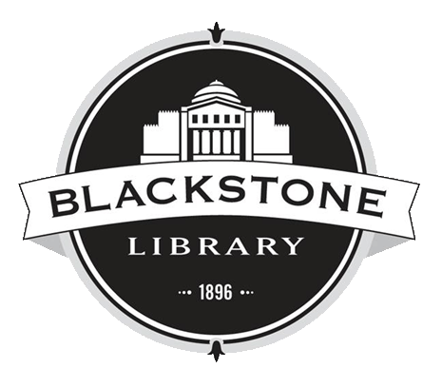
Questions ? (203) 488-1441 ext. 318 | www.blackstonelibrary.org

Helpful Hints for Nook COLOR
- With Overdrive Media App, Nook Color devices are compatible with the ePUB ebook format or Overdrive Mp3 audiobook format.

- “Add to Cart” will be displayed near all books with “Available” copies

- Up to 6 titles can be placed on hold at one time

- Audiobook lending period = 10 days | E-book lending period = 14 days

- Pop-up screens with tips: uncheck “Show…” then close to stop seeing pop-up.

Questions ? (203) 488-1441 ext. 318 | www.blackstonelibrary.org

Nook COLOR – Borrow and Download Books
** FIRST TIME USE:
- You must authorize device with a free Adobe ID to before downloading first book.

- You’ll only have to do this once.

- Follow prompts to get an Adobe ID online or visit www.adobe.com first.

Install App:
- Visit the App Store and search for OverDrive Media Console app
- Download & install app. Tap icon (blue square, white O) to open.
- Tap the menu icon, then "Get Books"
- Tap "Add a Library", enter 06405, tap James Blackstone Memorial Library, then tap Libraries Online tap on star to save library
- Tap on Libraries Online text to open catalog search for title

To find and search for books:
- Open app -> Tap menu tap Get Books Tap on Libraries Online text to open catalog
- Search or browse for title if available, tap “Add to Cart” or if not, “Request/Hold”
- Confirm check-out, then tap Download
- Tap for menu -> tap Bookshelf to display checked out items
- Tap title to open/read item (to change font size/color: Tap in bottom of screen to see options)

To Return Item Early (book will automatically be returned otherwise)

From the Bookshelf screen:
- Tap Plus (+) sign next to book
- Tap Return/Delete
In opened book:
- Tap for menu tap Return/Delete
- Tap Return then Delete

