**Now available**

**for check-out!**

**Ask at Reference!**

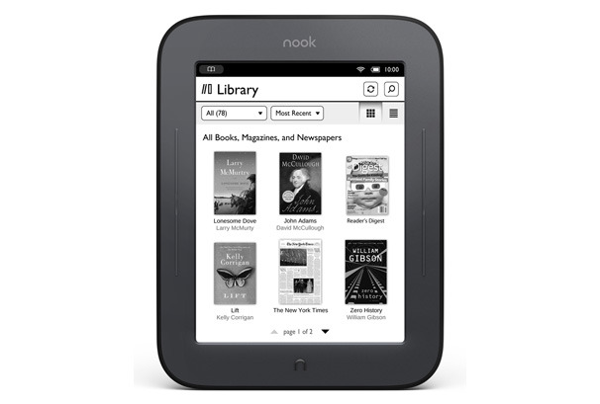

**Nook Touch**

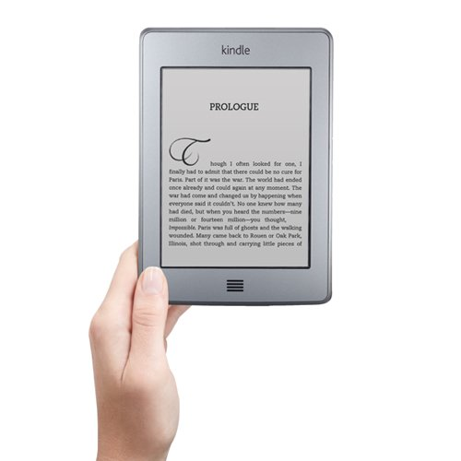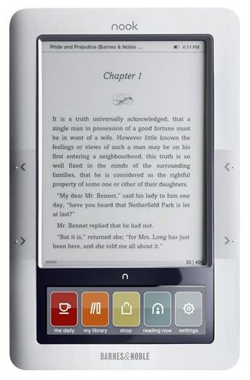

**Kindle Touch**

**Original Nook**