**KINDLE TOUCH QUICK START GUIDE**

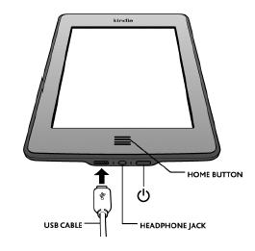

**Turn the Kindle Touch On or Off**

Tap the **power button**  to put the Touch to sleep/wake it up.

It is not necessary to completely turn the Touch off; simply put it to sleep when not in use.

**Find a book**

You'll find the library’s books in the main screen. To get to the main screen, press the **Home Button ** to display the eBooks. Then **tap the** **title** you wish to read.

**Open a book**

To open a book, **tap** on its title.

**Turn pages**

To turn the page of a book, **tap** or swipe the right or left edge of the screen to page forward or back.

**Access Menu and Toolbar**

To access reading options, change font size, or go to new location in the ebook, **tap the top** of the screen.

