**Follow these steps to get your digital magazines today!**

**—Create your Library Access account:**

* Visit www.blackstonelibrary.org and click the **Zinio** icon, or visit https://www.rbdigital.com/lioninc/service/zinio/landing
* Click “**Create New Account**” (upper right hand corner)
* Enter your library card number and click “**Next**.”
* Enter your name, email address, password (at least 7 characters with letters and numbers), and click on “**Create Account**.”

**—Choose and download magazines:**

* Click **“Browse Magazines.”**
* You can type in a **search for a title**, or click in the title search box to see a dropdown list, or click the “All Genre” box to browse by genre.
* Click on your desired magazine and click **“Checkout”**.
* A new window will open asking you to **create a Zinio account** or **log into an existing Zinio account**.
* The email address from the library account you created should appear in the email box. If it does not, enter the same email address you used to create your library account, type a password and click “**Continue**” to create your Zinio account.
* The magazine you selected will be in your Zinio account. To read on your PC or MAC, click “**Start Reading**” or choose “**Keep Browsing**” if you would like to choose additional titles.
* You can download the **Zinio Reader** for offline reading on your computer. You may need to install Adobe Flash to read in your browser. You may install the **Zinio App** for your mobile device.

**—Read Magazines on your mobile device**

* Download the **Zinio app** to your mobile device.
* **Open the Zinio app** on your mobile device and **log in** to your Zinio account.
* Download each magazine (may need to close/reopen the app to see new magazines)
* When the download is complete you can read your magazine(s) offline.

Zinio reader app downloads available for: PC / Mac / [iPhone / iPad](http://itunes.apple.com/us/app/zinio-magazine-newsstand-reader/id364297166?mt=8) / Android / Kindle Fire/HD / Win 8 / Blackberry / Nook HD/HD+

**Get started today!**

Visit https://www.rbdigital.com/lioninc/service/zinio/landing or go to **blackstonelibrary.org and click** **Zinio.**

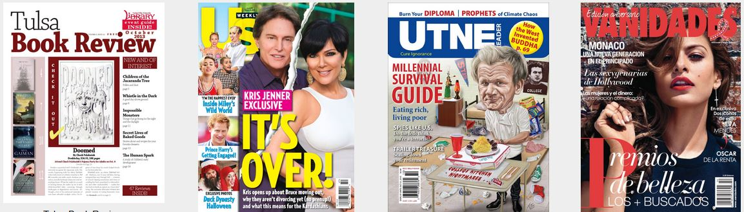

**Digital Magazines**

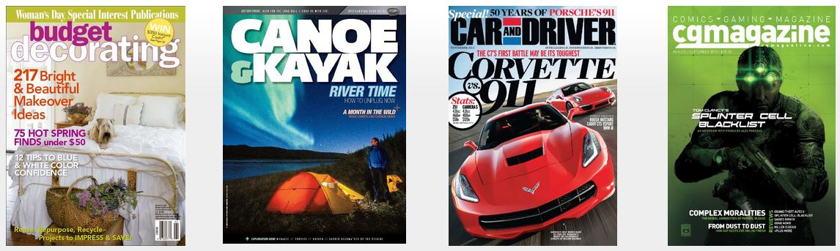

Get downloadable magazines via **Zinio**, the world's largest newsstand, offering **full color, interactive digital magazines** for your enjoyment. Browse from your library's collection of popular titles—with no holds, no checkout periods, and no limit to the number of issues you can download.   
  
**Current Issues** — New issues are released simultaneously with the print edition; many are available for download before they arrive at your library.   
  
**Easy browsing** — Browse your library's collection of titles one at a time, search for your favorite magazines by title or use the convenient category (Genre) feature to find new magazines which meet your interests   
  
**Manage your collection** — Using the personal account you will create, you will have the opportunity to checkout the magazines you choose and read them instantly on your computer (both PC and Mac) or access the content on a portable media device. (Note: viewing options, including the ability to download or view the content while online, may differ based on the device and/or magazine publisher)   
  
**No limits** — Check out as many issues as you want and keep them in your account as long as you wish   
  
**Note:** You will create a total of TWO (2) accounts; **a Library Access account to check out magazines**; and **a Zinio.com Reader account** to read checked out magazines via streaming online with computers and/or downloaded offline via mobile apps.

**Get started today!**

Go to **blackstonelibrary.org** and click **Zinio**

or visit: **https://www.rbdigital.com/lioninc/service/zinio/landing.**

** **

**Follow these steps to get your digital magazines today!**

**—Create your Library Access account:**

* Visit www.blackstonelibrary.org and click the **Zinio** icon, or visit https://www.rbdigital.com/lioninc/service/zinio/landing
* Click “**Create New Account**” (upper right hand corner)
* Enter your library card number and click “**Next**.”
* Enter your name, email address, password (at least 7 characters with letters and numbers), and click on “**Create Account**.”

**—Choose and download magazines:**

* Click **“Browse Magazines.”**
* You can type in a **search for a title**, or click in the title search box to see a dropdown list, or click the “All Genre” box to browse by genre.
* Click on your desired magazine and click **“Checkout”**.
* A new window will open asking you to **create a Zinio account** or **log into an existing Zinio account**.
* The email address from the library account you created should appear in the email box. If it does not, enter the same email address you used to create your library account, type a password and click “**Continue**” to create your Zinio account.
* The magazine you selected will be in your Zinio account. To read on your PC or MAC, click “**Start Reading**” or choose “**Keep Browsing**” if you would like to choose additional titles.
* You can download the **Zinio Reader** for offline reading on your computer. You may need to install Adobe Flash to read in your browser. You may install the **Zinio App** for your mobile device.

**—Read Magazines on your mobile device**

* Download the **Zinio app** to your mobile device.
* **Open the Zinio app** on your mobile device and **log in** to your Zinio account.
* Download each magazine (may need to close/reopen the app to see new magazines)
* When the download is complete you can read your magazine(s) offline.

Zinio reader app downloads available for: PC / Mac / [iPhone / iPad](http://itunes.apple.com/us/app/zinio-magazine-newsstand-reader/id364297166?mt=8) / Android / Kindle Fire/HD / Win 8 / Blackberry / Nook HD/HD+

**Get started today!**

Visit https://www.rbdigital.com/lioninc/service/zinio/landing or go to **blackstonelibrary.org and click** **Zinio.**



**Digital Magazines**



Get downloadable magazines via **Zinio**, the world's largest newsstand, offering **full color, interactive digital magazines** for your enjoyment. Browse from your library's collection of popular titles—with no holds, no checkout periods, and no limit to the number of issues you can download.   
  
**Current Issues** — New issues are released simultaneously with the print edition; many are available for download before they arrive at your library.   
  
**Easy browsing** — Browse your library's collection of titles one at a time, search for your favorite magazines by title or use the convenient category (Genre) feature to find new magazines which meet your interests   
  
**Manage your collection** — Using the personal account you will create, you will have the opportunity to checkout the magazines you choose and read them instantly on your computer (both PC and Mac) or access the content on a portable media device. (Note: viewing options, including the ability to download or view the content while online, may differ based on the device and/or magazine publisher)   
  
**No limits** — Check out as many issues as you want and keep them in your account as long as you wish   
  
**Note:** You will create a total of TWO (2) accounts; **a Library Access account to check out magazines**; and **a Zinio.com Reader account** to read checked out magazines via streaming online with computers and/or downloaded offline via mobile apps.

**Get started today!**

Go to **blackstonelibrary.org** and click **Zinio**

or visit: **https://www.rbdigital.com/lioninc/service/zinio/landing.**

**  **